**Template literals**

Template literals are new way used to create a string data first introduced in ES6 version. To create a template literal we use backtick (`) character instead double or single quotes.

Template literals are different from single & double quotes in the next:

1. Multi-lines and spaces are allowed within `string`. Instead of **\n** character.

**Example:**

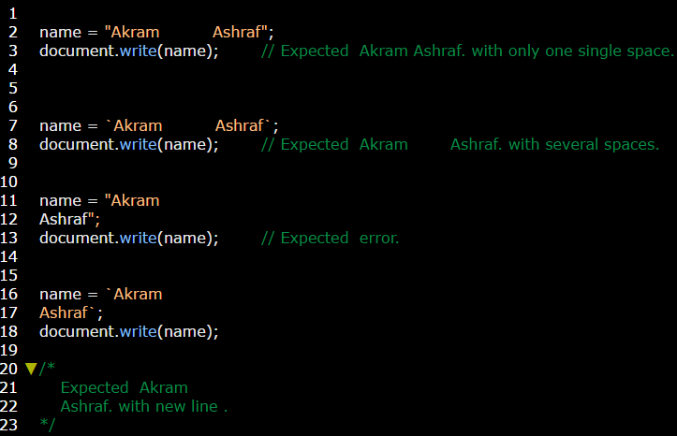

1. Called expressions are allowed within `string`; by using **${ }** symbol.

**Example:**

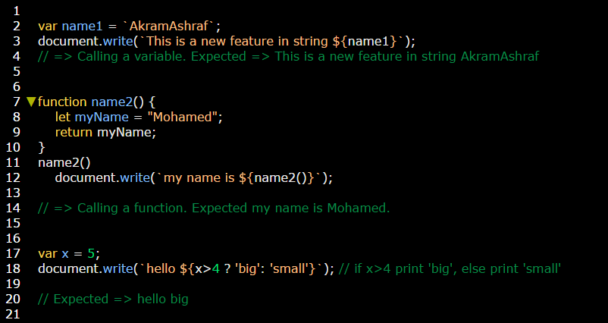

**There are more features in this link** <https://css-tricks.com/template-literals/>